CREDIT CONTRACT LANGUAGE
The below clip is from a Bank of America Visa Signature Card credit card contract.
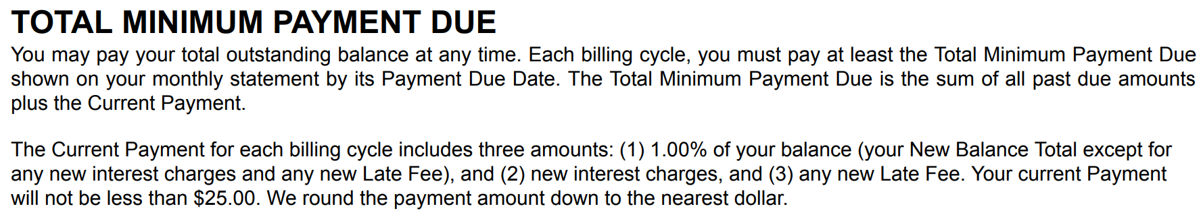
Circle language that you don’t understand.
What is the subtle statement that benefits the bank and not the card holder?

